<HTML> About the author <filename> “CO0005-Author.htm”</filename>
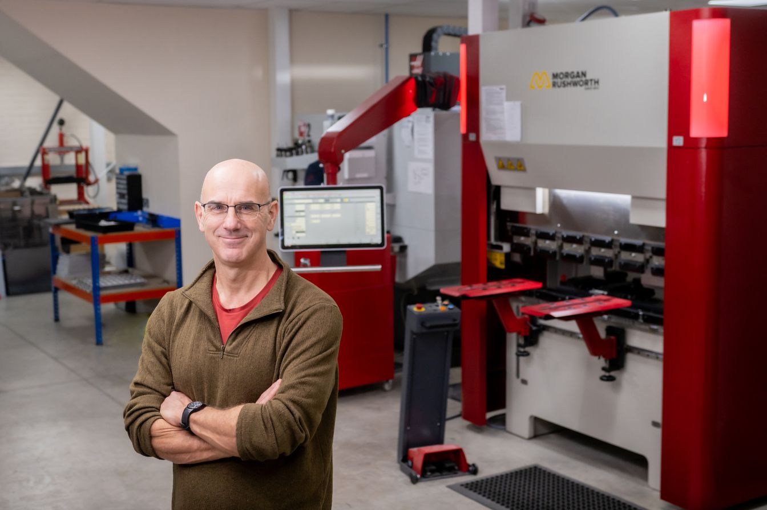
This course is written by John Dobson.
John Dobson is the Chairman of Matrix TSL.
Stuff I learned in putting this course together:
- This has taken me around 20 - 30 hours to put together. Maybe more.
- In general for a 60 hour course it will take a teacher 60 hours to plan a SOW and create presentations. A Scheme Of Work is a massive effort for teachers. It has a big value.
- Note that this course is probably not that high quality - I am not a teacher.
- There are not that many good PowerPoint slides available off the shelf online. Maybe there are if you pay for them. Loads of videos - but not necessarily good.
- AI is amazing at generating assessment. I wonder if it works?
- I have used AI to generate PowerPoint presentations. Varied quality output. But I have not tried hard. I don’t think it matters too much - we just need to be honest about what we have done. Certainly, the Powerpoints are a good start.
- Our transformers provision in terms of worksheets could be better. It would not take much to put this tougher and this is a major chunk of this unit.
- Customers may want a battery and a gearbox as part of the project work.
- We have discussed Applied Electrical Machines but not implemented it. That’s a shame - it would be really useful in this unit. Customers may want a gearbox separate from the Mechanical modules. It’s a key part. But at the moment they got to buy all add-ons.
- When we release a range of products we should produce a Scheme of Work. For example when we release Process Control 2 we should do this. Each machine is different. Students need to use them all.
- Worksheets need to be editable. For so many reasons……how are we gong to achieve this?
- We need to sort out whether we want to pursue this project and how much we are going to resource it.
- The Course Viewer and Splitter are Betas. We need to sort out what we want here and go to the next level.
</HTML>

<HTML> CPD objectives <filename> “CO0005-objectives.htm”</filename>

The objectives of this course are:
- Unit 16 of BTEC National: Electrical machines
- To deliver the understanding of the required content in the Syllabus
- To provide 60 Guided Learning Hours (GLH) of teaching
- To provide an additional 30 hours of homework to give a Total Qualification Time of 90 hours
To enhance the core engineering objective:
- MAKE is the core skill that we want to help our students become good at. For this reason there is a heavy emphasis on project work in this unit. Making skills require that students are able to integrate knowledge from different areas and apply it in a practical way. Ultimately, MAKE is what engineers do.
Teo become good at MAKEing students need to acquire a range of academic skills that are not defined purely by knowledge. We make an effort to give students to enhance these skills as they work through the syllabus.
- Math
- English
- IT
- AI
Working as part of a team is a key objective of this course. We give these skills focus with the following emphasis:
- Developing proposals
- Planning
- Communication
- Evaluation
This course is teacher centred - it is designed to show teachers how to deliver a course in Electrical Machines.
- It does not contain all of the teaching materials needed to deliver the course: these can be sourced elsewhere, or created by AI.
- It does contain a Scheme of Work needed to deliver this course. This includes
  - Structure of the course lesson by lesson
  - A plan that shows how the syllabus is delivered
  - Links to useful videos
  - Practical worksheets for use with Matrix equipment
  - Suggested homework
  - Suggested Assessment
  - Suggested project ideas
</HTML>

<HTML> Syllabus<filename> “CO0005-syllabus.htm”</filename>
This course is modelled directly on the requirements of the Pearson BTEC National Unit 16:Electrical Machines syllabus.
The following spreadsheet shows a summary of the learning objectives of this course
</HTML>
<HTML> Scheme of Work<filename> “CO0005-SOW.htm”</filename>
The Scheme of Work for this unit is given on the next screen.
The Scheme of Work also defines the structure and content of this course.
</HTML>

<HTML> Health and safety <filename> “CO0005-Equipment.htm”</filename>
Equipment required for this course:
- Modern Electrical Machines training system EM5154 including:
  - Power Supply
  - Dynamometer
  - DC motor
  - Single phase induction motor
  - Three phase induction motor
  - Series motor
  - Shunt motor
Transformers investigation equipment from Matrix TSL including:
- Transformers add-on kit EM4425
For the personal electric vehicle project students will need:
- Battery Simulator system EM0843
- Gearbox EMXXXX which is part of EM8622
For Make project work students can require access to lots of different types of motor, gear boxes, batteries etc. This depends on the projects that the students undertake.
For practical work ideally students should work in pairs. Groups of three at most.
Where students work in groups each student will be required to complete each worksheet and present it in a portfolio at the end of the course to achieve a grade.
</HTML>

<HTML> Assessment <filename> “CO0005-Assessment.htm”</filename>
In this course students will be given opportunities to:
- demonstrate practical and technical skills using appropriate processes, devices, components, equipment, materials, consumables
- complete realistic tasks to meet specific briefs or particular purposes
- write up the findings of their own research
- use case studies to explore complex or unfamiliar situations
- carry out projects for which they have choice over the direction and outcomes.
Assessment for this unit is as follows:
- Academic test at the end of the unit 50%
This will consist of a 2 hour question paper with 50 questions
- Portfolio of experiments 20%
Students are expected to submit worksheets for all experiments before the end of the unit.
- Project 30%
Students will work in pairs or threes to complete a project of their choice from the list of projects.
</HTML>

<HTML> Health and safety <filename> “CO0005-healthandsafety.htm”</filename>
Teacher will deliver a one hour lecture on Health and Safety in the workplace and in the lab.
</HTML>

<HTML> How this course is used? <filename> “CO0005-Course delivery.htm”</filename>

How much learning is there?
This course is 60 Guided Learning Hours - GLH.

Students are expected to spend an additional 30 learning hours on homework giving a Total Qualification Time - TQT - of 90 hours. The GLH consists of lectures, tests, practical sessions and project work.

How is the course put together?
Matrix courses consist of many media objects: Spreadsheets, small pieces of text, worksheets, videos, PowerPoints etc.

These appear in a sequence inside a browser.

The sequence and content of these objects is dictated by a Definition spreadsheet.

Much of the content is presented in small html files. These are defined in a single Content Word, or Google Docs, file.

How can the course content be changed?
The course is fully editable: by altering the Content file and the Definition file the content and structure of the course can be changed.

Similarly new courses can be assembled simply by copying and pasting content into new Definition spreadsheet and Content document.

How is the course used?
This course has been created by Matrix TSL to show how their equipment can be used to deliver a course in Electrical Machines.

This is primarily a planning tool for teachers:
- It allows them to organise a course based on a Scheme of Work - the Definition spreadsheet.
- It allows them to define lesson plans as part of the scheme of work
- It allows them to organise the worksheets that manage practical activities
- It allows them to map the syllabus to the Scheme of Work

The course is teacher centred. It can also be presented as it is to students to show them the course ahead of them. Or a student version can easily be created from it.

SCORM compliance
Many institutions have a Learning Management System like Moodle or Blackboard. The content of this course is compatible with these systems through the SCORM standard. A SCORM file containing all of the assets in this course can be downloaded and inserted into any SCORM compatible LMS.
</HTML>

<HTML> Electromagnetism <filename> “CO0005-Electromagnetism.htm”</filename>
Teacher should deliver a two-hour lecture in Electromagnetism.

Students should have learned this in another unit, but it would be prudent to refresh their memories at this point.

We have used Chat GPT with the following brief to create a PowerPoint:

Create for me 20 PowerPoint style slides on Electromagnetism covering the following topics:
Force on a Current-Carrying Conductor
Force on a Conductor at an Angle
Magnetic Flux Density
Magnetic Circuit – Reluctance
R= l/(µo x µr x A)
Magnetic Circuit – Magnetising Force
Induced Voltage (Faraday's Law)
Generator EMF
E= B x l x v
Transformer Induced Voltage
Use: Emax = N x A x B x ω
Where: ω = (2 x π x n) / 60

You can see this PowerPoint on the next screen. This would be a good start to help you develop a PowerPoint of your own. If this does not quite serve your purposes then you can create your own PowerPoint or you can alter the description above and resubmit this to AI.

</HTML>

<HTML> Homework 1 <filename> “CO0005-homework1.htm”</filename>

Students should watch the following videos on Electromagnetism.

Magnets, lines of flux, toroid, solenoid
https://youtu.be/ERLT2Kc6iYw?si=iJIngIFvHRHNJUnC

MMF, Field strength, flux density, reluctance
https://youtu.be/JtQIpy0n4TA?si=YJTyNumKyRpRt-O7

Magnetic circuits
https://youtu.be/zNlmCiVThB4?si=BfgDoegUVERIQ_ty

Analysis of magnetic circuits
https://youtu.be/HRGsgPCZFXg?si=Gdq726D5o23BQRRB

Magnetisation curves, hysteresis
https://youtu.be/UOPxWW-PZwY?si=fhNGvBZ-8O95KZXT

Faraday's law, Lenz's law, eddy currents
https://youtu.be/8bRoBX6LjY8?si=C8zWpLHqGInsQ-5h

Force on a conductor
https://youtu.be/-YtLSgFsLyo?si=WwCZKngCdo7ZPf63

Induced voltage
https://youtu.be/yrwGbdsrhGE?si=rggIQihoC-jDjfqE

We have used Chat GPT to create the following questions.

take your time to work through these and then answer the following questions.

1. Force on a Current-Carrying Conductor
A straight conductor 0.40 m long carries a current of 12 A perpendicular to a uniform magnetic field of 0.8 T.
Calculate the force acting on the conductor.
2. Force on a Conductor at an Angle
A conductor 0.75 m long carries a current of 15 A and is placed in a magnetic field of 0.6 T at an angle of 45° to the field.
Calculate the magnetic force acting on the conductor.
3. Magnetic Flux Density
A conductor carrying 8 A experiences a force of 2.4 N when placed at right angles to a magnetic field. The conductor length is 0.25 m.
Determine the magnetic flux density.
4. Magnetic Circuit – Reluctance
A magnetic core has:
- Mean magnetic path length = 0.45 m
- Cross-sectional area = 4 × 10⁻⁴ m²
- Relative permeability = 1500
Calculate the reluctance of the magnetic circuit.
Use: R= l/(µo x µr x A)
5. Magnetic Circuit – Magnetising Force
A magnetic core has:
- Number of turns = 500
- Current = 2 A
- Mean magnetic path length = 0.50 m
Calculate the magnetising force (H).
6. Magnetic Flux in a Magnetic Circuit
A magnetic circuit has:
- MMF = 1200 A-turns
- Reluctance = 4.0 × 10⁵ A-turns/Wb
Calculate the magnetic flux produced.
7. Induced Voltage (Faraday's Law)
A coil of 250 turns experiences a change in magnetic flux from 0.015 Wb to 0.005 Wb in 0.04 s.
Calculate the induced voltage (EMF).
8. Generator EMF
A conductor of length 0.35 m moves at 18 m/s perpendicular to a magnetic field of 0.9 T.
Calculate the induced voltage across the conductor.
Use: E= B x l x v
9. Transformer Induced Voltage
A transformer primary has 600 turns connected to a 240 V AC supply. The secondary has 150 turns.
Calculate the secondary voltage.
10. Rotating Coil Generator
A coil has:
Number of turns = 150
Area = 0.012 m²
Magnetic field strength = 0.6 T
Rotational speed = 1200 rpm
Calculate the maximum induced EMF.
Use: Emax = N x A x B x ω

Where: ω = (2 x π x n) / 60

</HTML>

<HTML> Electromagnetism <filename> “CO0005-Electromagnetisminnumbers.htm”</filename>

Teacher will go through the homework questions with whole class and make sure students understand.

</HTML>

<HTML> Electromagnetism <filename> “CO0005-DC motor.htm”</filename>

Teacher will deliver a two hour lecture in DC motor operation:

B2:
- Purpose of pole segments and field windings to create a fixed magnetic field, as determined by Fleming’s right-hand rule.
- Interaction of the fixed magnetic field with an armature winding to create movement, as determined by Fleming’s left hand rule and rotation due to the armature being fixed at a central pivot point.
- Connection of the field and armature windings to create three types of DC motor, series, shunt and compound, and the difference in operation between all three.
- Construction of the rotor with conductor coils embedded within a laminated iron core to increase magnetic field strength and reduce power losses due to eddy currents.
- Purpose of input voltage commutation and how the commutator component achieves this.
- Starting issue with the use of single commutator segments and how these issues are minimised.
- Current contact with the armature windings through carbon brushes and the reasons for using carbon, to include good electrical conductivity, self-lubricating material and reduced switching noise.

- Measurement of speed and torque characteristics in DC motors (series, shunt and compound) to include:
- input current and input voltage
- power output Pout =(2 x π x τ x N) / 60 and motor efficiency, η = Pout / Pin

</HTML>

<HTML> Machine construction <filename> “CO0005-DC machine construction.htm”</filename>
Teacher should deliver a one hour lecture in DC machine construction.

We have used Chat GPT with the following brief to create a PowerPoint:

Create for me 20 PowerPoint style slides on DC Electrical Machines covering the following topics:
Simple DC motor construction and operation
Split rings and carbon brushes
Fleming’s left and right hand rule
Stators and rotors
DC machines with permanent magnets in the stator
DC machines with electromagnets in the stator
Starting issues
Examples of DC motors in use: Car starting motor
DC generators or dyamos
Examples of dynamos in use: bicycle
You can see this PowerPoint on the next screen. This would be a good start to help you develop a PowerPoint of your own. If this does not quite serve your purposes then you can create your own PowerPoint or you can alter the description above and resubmit this to AI.
</HTML>

<HTML> Electromagnetism <filename> “CO0005-other DC machines.htm”</filename>
Teacher should deliver a one hour lecture in other types of DC machine:

We have used Chat GPT with the following brief to create a PowerPoint:

Create for me 10 PowerPoint style slides on DC Electrical Machines covering the following topics:
Shunt motors
Series motors
Car starter motor as an example of a Series motor
Give an example of the number of amps and volts in car starter motor
Give an example of the circuit of a starter motor showing the solenoid.
You can see this PowerPoint on the next screen. This would be a good start to help you develop a PowerPoint of your own. If this does not quite serve your purposes then you can create your own PowerPoint or you can alter the description above and resubmit this to AI.
</HTML>
<HTML> Power efficiency calculations <filename> “CO0005-power efficiency.htm”</filename>
Teacher should deliver a one hour lecture in power in Electrical machines

We have used Chat GPT with the following brief to create a PowerPoint:

Create for me 10 PowerPoint style slides on power in Electrical Machines covering the following topics:
Input and output power in electrical machines
input voltage and output voltage of generators
power output Pout =(2 x π x τ x N) / 60
motor efficiency, η = Pout / Pin
You can see this PowerPoint on the next screen. This would be a good start to help you develop a PowerPoint of your own. If this does not quite serve your purposes, then you can create your own PowerPoint or you can alter the description above and resubmit this to AI.
</HTML>

<HTML> Homework 2 <filename> “CO0005-homework2.htm”</filename>

To write

</HTML>

<HTML> Speed, torque and motor applications <filename> “CO0005-speed torque applications.htm”</filename>

Students have now looked at quite a few characteristics of motors.
Teacher should give a one hour lecture in:
- Understanding speed torque curves
- Different applications of motors and where each type of motor is used.
- Applications of DC motors

</HTML>

<HTML> Speed control in DC motors<filename> “CO0005-speed control dc motors.htm”</filename>

Teacher should give a one hour lecture in:
- Speed control of DC motors and associated circuitry
- Overload protection
- Use of rheostats (old style control)

</HTML>
<HTML> Transformers<filename> “CO0005-transformers.htm”</filename>

Teacher should give a two hour lecture in:
- transformers

</HTML>

<HTML> Homework 3 <filename> “CO0005-homework3.htm”</filename>

To write

</HTML>

<HTML> Induction motors<filename> “CO0005-induction motors.htm”</filename>

Teacher should give a one hour lecture in:
- Field windings in a single-phase AC motor generate a magnetic field.
- The smoothness of the machine’s rotation is determined by the number of pole pairs that each create an additional magnetic field.
- Single-phase AC motors require starting circuitry to set up a magnetic field allowing the motor to operate.
- Single-phase AC generators produce an AC waveform, where the terminal voltage is proportional to the speed of rotation.
- Function of single phase AC induction motors

</HTML>

<HTML> Three phase motors<filename> “CO0005-Three phase motors.htm”</filename>

Teacher should give a two hour lecture in:
- The stator in three-phase induction motors generates a rotating magnetic field. f
- Synchronous speed is calculated by nsync = f x 60/P
- Wound rotors and squirrel-cage rotors use laminations in the core to reduce power losses.
- Understand how a current is induced in the rotor bars or windings and how this current produces torque in the rotor.
- For wound rotor motors the purpose of slip rings and brushes is to continuously connect the windings to the alternating power supply during operation. Benefits of wound rotor motors in using starting circuits include access to the windings so that increased resistance can be added and removed in resistance starters.
- Definition of slip speed is the difference between shaft speed and synchronous speed and n also how to determine slip as a percentage of the rated speed (nsync - nm) / nsync

</HTML>

<HTML> Homework 4 <filename> “CO0005-homework4.htm”</filename>

To write

</HTML>

<HTML> AC motor control<filename> “CO0005-AC motor control.htm”</filename>

Teacher should give a two hour lecture in:
- Speed control of three-phase induction motors to include variable frequency drives, inverters and pulse width modulation (PWM) systems.
- Measurement of single- and three-phase induction motor characteristics to include:
  - single-phase motor currents on start-up and the phase shift required to self-start
  - synchronous speed for an induction motor with a known number of poles
  - motor shaft speed and motor slip
  - torque versus speed for induction motors.
- Input power, current and voltage using SQR(3 x Vl x Vi x cos(φ) and output power using Pout =(2 x π x τ x N) / 60 to calculate the efficiency of the induction motor.

</HTML>

<HTML> Other electrical machines<filename> “CO0005-other electrical machines.htm”</filename>

Teacher should give a one hour lecture in:
- Brushless motors
- Brushless motors as a three phase generator

</HTML>

<HTML> Portfolio and project<filename> “CO0005-portfolio and project.htm”</filename>

Teacher should show students how to present a portfolio of the work that they have done in the practical sessions. Whilst students have done this in pairs or threes, each student will be expected to submit their own portfolio of worksheets.

Teachers should also prepare students for the project work that is to come.

Students have a choice of projects:

Project 1: Build a transformer
Use laminations and copper wire to build a transformer of your choice.
Add a rectifier circuit and a capacitor
Devise a test rig with resistors and measure the performance of your power supply.

Project 2: Create a personal electric vehicle
Specify and build a personal electric vehicle. The vehicle should achieve set speed, and torque, It should be capable of travelling for a set number of kilometers with a given battery life.

For all projects students should create
- A proposal
- A plan
- A test document
- A description of the project and how it went
- Diagrams test results
- A discussion of how AI was used to help in the project and how the AI was verified

Students should carry out the project in pairs

</HTML>

<HTML> Project work<filename> “CO0005-project work.htm”</filename>

To write

</HTML>

<HTML> Project work<filename> “CO0005-project homework.htm”</filename>

To write

</HTML>

